Milestone 1: Prep (Planning Phase)

Chris King

CST-451 Capstone Project Proposal

Grand Canyon University

Professor Mark Reha

0.0 (Revision)

09/23/2022

**ABSTRACT**

The peak of cutting-edge technology can be defined by many different subjects. Embedded systems, cloud computing, API; many of these represent the true power that technology is capable of. However, there is one large, powerful area of technology that cultivates a particular interest; artificial intelligence. What makes AI so powerful is its applicability in the real world. There are almost no limits to what you can apply AI to. From making arguably self-aware robots that can be your best friend, artists, all the way to creating an intelligent, automated process behind your application’s fundamental processes. For this project, an AI model will be created and designed to be able to be mounted on different systems.

The problem with current industry-level AI is its portability; AI today feels more like a software application than an individual entity. The goal of this project is to lay a foundation to solve exactly this problem, by creating an AI model that’s ‘portable’, in that it can be transported from environment to environment with relative ease. With inspiration taken from multiple science-fiction movies, an AI model with this level of portability will kickstart the solution of creating an AI that is more entity than application. The key function to this portability is to give this AI model the ability to learn things it wasn’t specifically programmed to learn.

|  |
| --- |
| History and Signoff Sheet |

**Change Record**

|  |  |  |
| --- | --- | --- |
| **Date** | **Author** | **Revision Notes** |
| 09/23/2022 | Chris King | Initial draft for review/discussion |
| 09/25/2022 | Chris King | Initial Submission |
|  |  |  |

|  |
| --- |
| **Overall Instructor Feedback/Comments**  Reduce Abstract to two paragraphs  Bullet point Project Technologies and Project Scopes - Templatizing Project Scope using Jira is a good idea  Include any final/bonus objectives in the project |

|  |
| --- |
| **Overall Instructor Feedback/Comments** |

**Integrated Instructor Feedback into Project Documentation**

☐ Yes

**Project Approval**

☐ Professor Mark Reha

**TABLE OF CONTENTS**

**Project Overview and Project Objectives 4**

**Project Scope 5**

**Project Success Measures 7**

**Project High-Level Solution 8**

**Project Controls 9**

**Project Cost and Schedule 11**

**Appendix A – Project Diagram 13**

**Appendix A – Copyright Compliance 13**

**Project Overview and Project Objectives**

**State the Problem and Background**

Though AI has an incredibly powerful applicability, the problem is most industry-standard AI is treated more like a software application than an actual entity. A standard industry AI model has limited dynamics, and is tailored towards a specific purpose with little ability to be applicable anywhere else. For example, Replika, arguably one of the most advanced language processing AI available to the public, is extremely well-versed in AI technology, and many different subjects that are commonly talked about amongst humans. However, this AI isn’t capable of even simple mathematics, or programming principles. Not only that, but it is unable to learn subjects like these through conversation as it simply doesn’t have the capability to do so, as it does other subjects. This project is being undertaken to approach this problem by developing an AI model that functions like an individual entity, rather than a software application.

**Project Objectives**

**Objective 1:** An AI model must be created. There are no advanced requirements to the capabilities of this AI model at this point, however, this model must have a purpose. The current in-scope purpose of this AI model is Natural Language Processing.

**Objective 2:** this AI model must be able to be mounted on an external device. For this project, a Raspberry Pi will be used. This AI model must be able to be placed, and function (run), on a Raspberry Pi, or a Raspberry Pi-Powered device.

**Objective 3:** Communication must be established to this AI model from an external device. There are many different ways to accomplish this. However, the idea is simply to be able to send prompts and receive responses from the AI via a separate device such as a computer, or in an otherwise external manner. Continuous Deployment must be established; that is, this AI will be “awake”, or running, until powered off.

**Objective 4:** This AI model must be “portable”. That is, if I were to theoretically want to transfer this AI model from one Raspberry Pi to another, I would be able to do so as if it were an entity, maintaining its memory and any past training. At this point in time, portability between significantly different machines isn’t required, and being able to function on raspberry pi’s with, say, different functions, will suffice.

**Objective 5 (BONUS OBJECTIVE):** To really put this model’s portability to the test, it will be planted on a HiWonder SpiderPi, an open-source Raspberry-Pi powered robotic hexapod. Communication with the AI model as it’s planted in this environment will essentially make for an intelligent SpiderPi.

**Project Scope**

The scope of this project has been divided into two phases: The first phase (In Scope), and the Second Phase (Out of Scope). Only after successful completion of the first phase will the second phase be approachable. Below, the current in-scope and out-of-scope objectives are listed.

* **In-Scope**
  + As a user, I would like to communicate back and forth directly with an AI model.
  + As a developer, I would like to transfer this AI model onto another device, while maintaining its memory and functionality.
  + As a developer, I would like to transfer this AI model onto a Raspberry Pi, while maintaining its memory and functionality.
  + As a user, I would like to establish connection to this AI model from an external device, such as a personal computer.
  + As a user, I would like to communicate back and forth with this AI model from an external device, such as a personal computer.
  + As a user, I would like to maintain simple, natural conversation with this AI model.
  + As a developer, I would like this AI model to possess persistent deployment (Running, like a program, until powered off).
  + As a developer, I would like to be able to train this AI model on an external device, such as a personal computer.

* **Out-Of-Scope**
  + As a developer, I would like to be able to train this AI model on-board continuously.
  + As a developer, I would like to be able to develop a relationship between the AI model and its current environment.
  + As a developer, I would like this AI model to develop a level of functionality or interaction over the environment it’s currently in.
  + As a developer, I would like this AI model to have a high-level intelligence over relevant technologies, such as Artificial Intelligence, and the technologies it is involved with, or relevant to its existence.
  + As a user, I would like to make commands to this AI
  + As a developer, I would like this AI to perform commands, in conversation, and in interaction with their environment.
  + As a developer, I would like this AI to maintain an intermediate level of self-awareness.
  + As a developer, I would like to be able to test this model’s portability by mounting it on a HiWonder SpiderPi, and establish communication with it via an external device, such as a personal computer. (This requirement is currently in-scope, but can be moved to out-of-scope depending on the success of the above requirements)

**Project Success Measures**

The Project Success will be measured SOLELY on the completion of the in-scope objectives, outlined in the first phase. As time passes, objectives might be pulled from out-of-scope, and into scope depending on the success of in-scope objectives.

The SpiderPi objective also contributes to the success of this project. However, while this objective is in-scope currently, if it can not be accomplished it will be moved to out-of-scope. The goal of this project is focused on the AI model itself rather than the SpiderPi, so the success of the SpiderPi objective will not determine the success of the AI model, and the project as a whole.

The out-of-scope objectives are objectives that are not required as part of this project’s success, but are objectives that may be approached come the complete success of the objectives that are in-scope.

**Assumptions and Constraints**

|  |  |  |  |  |  |
| --- | --- | --- | --- | --- | --- |
| Assumptions and Constraints | | | | | |
| ID | Description | Comments | Type | Status | Date Entered |
| 1 | Memory/Storage | Memory and Storage is a constraint of this project. Our Raspberry Pi might not contain the memory or storage required to support an AI NLP Model (Natural Language Processing) | Constraint | Active | 09/23/2022 |
| 2 | SpiderPi Capabilities | Right now, the HiWonder SpiderPi is limited to a 4GB Raspberry Pi. This poses a constraint issue to what we can perform on this spider. Luckily, Pi spiders are very modular and external SSDs and other equipment can be purchased and mounted. | Constraint | Active | 09/24/2022 |

**Project High-Level Solution**

**Introduction**

The challenge being approached is industry AI. Today, AI is handled like a software application, used to either support another software application, or to connect a user to information that’s already available. Research in developing AI that acts as an individual entity is still relatively new in the industry, and this project will act as a contribution to that research.

**Solution**

An AI NLP Model (Artificial Intelligence, Natural Language Processing) will be developed on a personal computer, using TensorFlow and Python, and then planted onto two different Raspberry Pi environments. Below is a block diagram showing the interconnection of this project (*Appendix A, Project Diagram*).

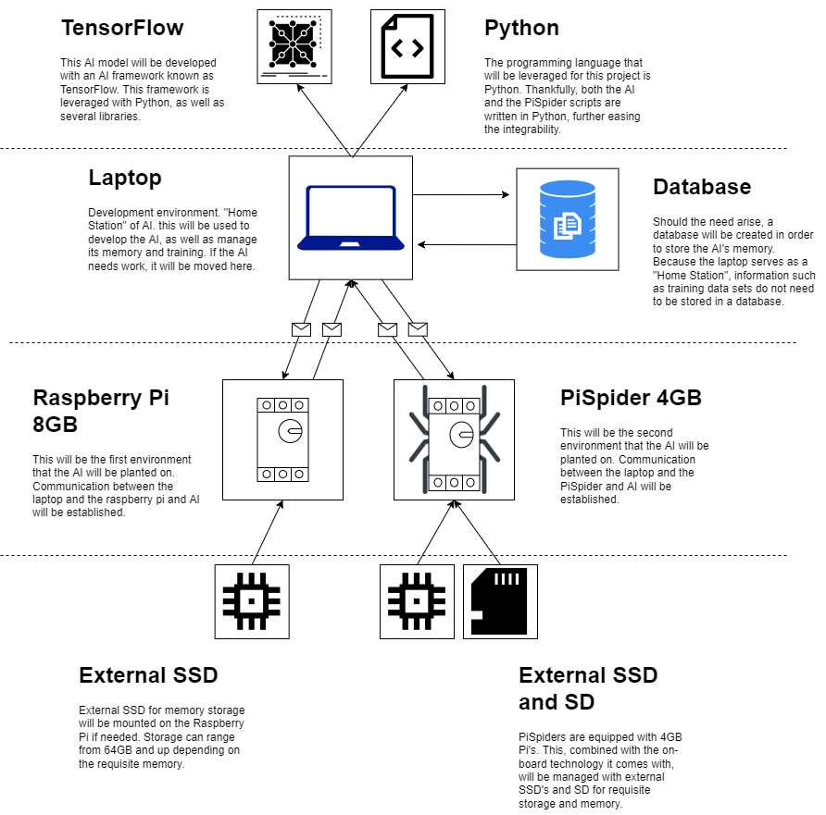

**List of Technologies**

* **MSI GS76 Stealth Laptop**
  + **TensorFlow Version 2**
  + **Python Version 3**
  + **MySQL Database**
  + **Jupyter Local Development Server**
* **Raspberry Pi 4 8GB Kit 8GB RAM**
  + **External SSD Memory Storage 64GB+**
  + **5V 3.6A Type C Power Supply**
  + **64GB SD Card**
* **HiWonder PiSpider Advanced Kit**
  + **External SSD Memory Storage 64GB+**
  + **External MicroSD Card 16GB+**
  + **Raspberry Pi 4B 4GB RAM**
  + **5V 3.6A Type C Power Supply**
  + **Onboard SpiderPi Technologies**

**Project Controls**

|  |  |  |  |  |
| --- | --- | --- | --- | --- |
| Risk Management | | | | |
|  | **Risk Probability** | **Risk Impact** |  |  |
| **Event Risk** | **(high, medium, low)** | **Risk Mitigation** | **Contingency Plan** |
| What is the risk? | What is the probability? | What is the impact if the risk occurs? | What can be done to minimize the risk? | What can be done to minimize the impact of the risk? |
| NLP  Never worked with developing a NLP model. | 100% | Possible AI model rollback to computer vision | Currently enrolled in professional Coursera certificate courses to learn NLP, combined with research on previous TensorFlow NLP projects. | Designing a Plan-B rollback contingency to a computer vision AI model, which I have experience in already. A net to fall back on, with equal acceptability and integrability for the project as a whole. |
| Raspberry Pi Constraints  Raspberry Pi memory and storage constraints may conflict with requirements to support an AI model | 60% | Worst-Case Scenario, Moving of SpiderPi objective to out-of-scope | Research common NLP and Computer Vision AI model storage and memory constraints. Generate a list of general specifications. | Preparing External SSD for Raspberry Pi’s, to handle memory and storage intensive functionalities such as training. |
| NLP Memory  Never worked with storing the memory of an NLP model. Database requirements, etc. | 100% | Possible AI model rollback to computer vision | Currently enrolled in professional Coursera certificate courses to learn NLP, combined with research on previous TensorFlow NLP projects. | Designing a Plan-B rollback contingency to a computer vision AI model, which I have experience in already. A net to fall back on, with equal acceptability and integrability for the project as a whole. |
| Continuous Deployment  Never worked with an AI model being “awake” continuously | 85% | Possible rollback to Computer Vision | Through the enrollment of coursera courses, experience with CD of AI will be obtained. CD seems to be specifically tailored towards NLP and communication AI, as Computer Vision works off of simple send and response. | Designing a Plan-B rollback contingency to a computer vision AI model, which I have experience in already. A net to fall back on, with equal acceptability and integrability for the project as a whole. |
| SpiderPi  Never worked with SpiderPi before | 85% | Worst-Case scenario, moving of SpiderPi objective to out-of-scope | Researching SpiderPi, and reading reviews on HiWonder’s website. This risk involves the open-source of the spider’s code. Reading reviews of people who have worked on a SpiderPi will give me an idea of its modularity. | Designing the project as a whole, ensuring that the project can continue if the SpiderPi must be moved to out-of-scope, as a contingency if no other options are available. |
| Inter-device communication  Lack of experience of Pi’s creates a risk of communication between the pi and an external device. | 50% | Research on implementation of different communication strategies. Minimal Impact. | Researching past Pi-Powered AI projects and how communication was established with those. | Generating a list of possible communication systems for a raspberry pi and an external device. This will provide multiple options for a system of communication, should one not work out. |
| Inter-device communication  Lack of experience with communication between the AI model on a separate device | 85% | Movement of Spider-Pi to out-of-scope. Danger to performance via the need of external communication services. | Researching past Pi-Powered AI projects and how communication was established, as well as testing communication from computer-to-computer or with Virtual Machines. | Utilization of an external service of communication, such as an API, will act as a contingency. However, this will pose a hindrance to the performance of communication as it will be slower than a direct line of communication. |

The below issue log will be utilized once one of the above risks are encountered. If a risk is encountered that is not listed in the Risk Log, it will be added to the Risk Log and documented below.

|  |  |  |  |  |  |  |  |  |
| --- | --- | --- | --- | --- | --- | --- | --- | --- |
| Issues Log | | | | | | | | |
| **ID** | **Description** | **Project Impact** | **Action Plan/Resolution** | **Owner** | **Importance** | **Date Entered** | **Date to Review** | **Date Resolved** |
| 1 | What is the issue? | How will this impact scope, schedule & cost? | How do you intend to deal with this issue? | Who manages this issue? |  |  |  |  |
| 2 |  |  |  |  |  |  |  |  |
| 3 |  |  |  |  |  |  |  |  |

All projects have either anticipated and planned or unexpected changes. Any issues in management or change management due to the anticipated and planned or unexpected changes. Anticipated and planned or unexpected changes will be documented below, should they arise.

|  |  |  |  |  |  |  |  |  |  |
| --- | --- | --- | --- | --- | --- | --- | --- | --- | --- |
| Change Control Log | | | | | | | | | |
| **ID** | **Change Description** | **Priority** | **Originator** | **Date Entered** | **Date Assigned** | **Evaluator** | **Status** | **Date of Decision** | **Included in Rev. #** |
| 1 |  |  |  |  |  |  |  |  |  |
| 2 |  |  |  |  |  |  |  |  |  |

**Project Cost**

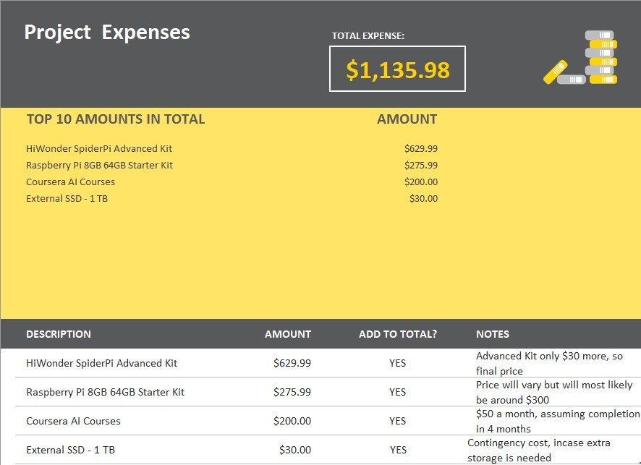

**Project Timeline/Schedule**

|  |  |  |  |  |  |  |  |  |  |
| --- | --- | --- | --- | --- | --- | --- | --- | --- | --- |
| ID | Task | Dependencies | Status | Effort Hours | Cost | Start Date | Planned Completion | Actual Completion | Resource |
| 1 | 451-Milestone 1:  Project Proposal | None | Done | 8hrs | Time | Week 1 | Week 3 | Week 3 | Professor Reha, Mentor Hilal, Online resources |
| 2 | 451- Milestone 2:  Requirements + User Stories | Completion of previous milestone | Defined | 3 days | Time | Week 4 | Week 7 |  | Professor Reha, Mentor Hilal, Online resources |
| 3 | 451-Milestone 3:  Final Architecture Plan | Completion of previous milestone | New | 5 days | Time | Week 8 | Week 12 |  | Professor Reha, Mentor Hilal, Online resources |
| 4 | 451-Milestone 4:  Start of coding and development | Completion of previous milestone | New | 10 days | Time | Week 13 | Week 15 |  | Professor Reha, Mentor Hilal, Online resources |
| 5 | Micro Frontend POC | Basic Understanding of all necessary page components and categorize them | New | 6hrs | Time | Week 14 | Week 3 |  | Professor Reha, Mentor Hilal, Online resources |
| 6 | 452-Milestone 1:  Continue coding and testing | Completion of previous milestone’s user stories/tasks | New | 10 Days | Time | Week 1 | Week 5 |  | Professor Reha, Mentor Hilal, Online resources |
| 7 | 452-Milestone 2:  Continue coding and testing | Completion of previous milestone’s user stories/tasks | New | 10 Days | Time | Week 6 | Week 10 |  | Professor Reha, Mentor Hilal, Online resources |
| 8 | 452-Milestone 3: Final Project | Completion of previous milestone’s user stories/tasks, and all in scope functionality | New | 10 Days | Time | Week 11 | Week 15 |  | Professor Reha, Mentor Hilal, Online resources |

**Appendix A – Project Diagram**

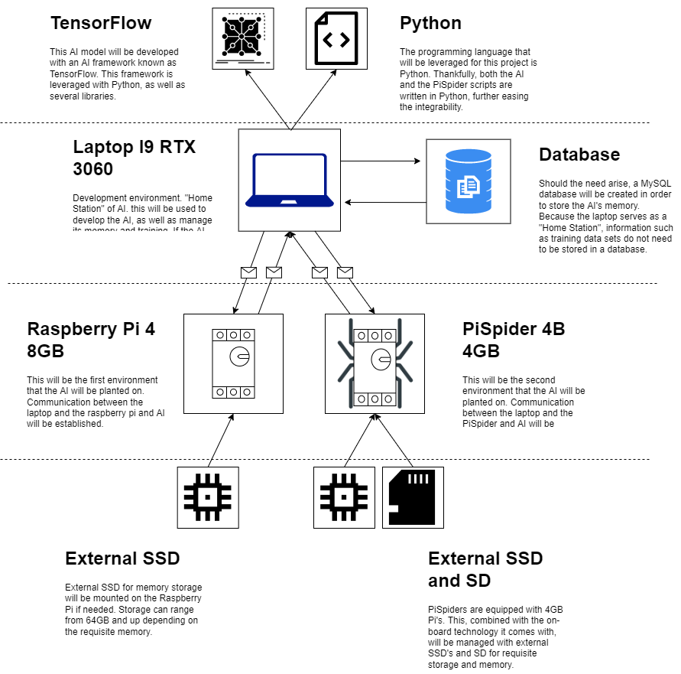

**Appendix B – Copyright Compliance**

SpiderPi:

*Terms of service*. Hiwonder. (n.d.). Retrieved September 24, 2022, from https://hiwonder.hk/pages/terms-of-service